

CENTENNIAL COLLEGE PROGRESS CAMPUS

COURSE COMP306

Lab work #01

**Hello My Team Members!**

How was your AMAZING day?

Here are some warmup steps for completing session one.

Please answer these questions **individually** and prepare a 5-minute presentation for your group (just the presentation part is a team-work) in order to share your achievements with other teams. Feel free to use PowerPoint, whiteboard or anything you like.)

**Questions** (Estimated time to complete the questions is 2 hours)

1. What are the differences between Web Services and Cloud Services?

A **web service**:

* Communicates through HTTP
* API allows users to interact with software over the Internet
* Provides data for applications to consume

A **cloud service**:

* Infrastructure/platform
* Provides resources which allow web services to be hosted and be accessible through the web

1. What is Hypervisor?

A **hypervisor**:

* aka Virtual Machine Monitor (VMM)
* creates and runs virtual machines
* a computer that runs one or more VMs is called the host machine
  + each VM is called a guest machine on that host machine
  + the guest machine shares hardware and resources of the host machine
* Two types of hypervisors
  + Type 1: “bare metal” runs directly on the system hardware
    - E.g. Microsoft Hyper-V
  + Type 2: runs on a host operating system that provides virtualization services
    - E.g. VMWare Fusion, Oracle VirtualBox Parallels, and VMWare Workstation

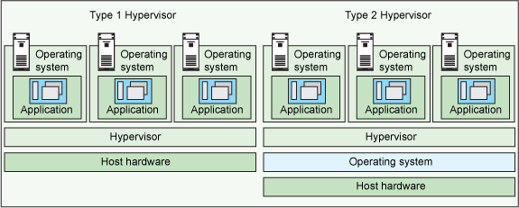

1. What is Edge-assisted cloud?

**Edge** computing:

* With typical cloud computing, most utilize public clouds such as Amazon, Microsoft, Google, and IBM
* With Edge computing, computing gets done at or near the source of data, instead of relying on the cloud at one of the few data centers around the world
* Resolves cloud’s challenge of latency issues
  + Data generated at the edge allows real-time decisions

1. What is peer-to-peer cloud?

**Peer-to-peer cloud**:

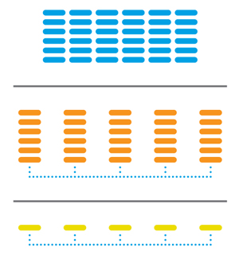

* Cloud computing model
  + All hardware in one data center
  + Hardware split up over multiple data centers
  + Peer-to-peer cloud made up of individual computers
    - Combine resources of the individual computers to power the cloud

1. What is Container as a Service?

**Container as a Service** (CaaS):

* A subset of IaaS (Infrastructure as a Service)
  + Difference is that it focuses on containers as opposed to bare metal systems and virtual machines
* Provides easy way to set up a container cluster
* Orchestration platform
  + E.g. Google Kubernetes, Docker Swarm, Rackspace Carina and Apache Mesos

1. What is Data Center?

**Data Center**:

* Centralized locations where infrastructure resources and stored for the purpose of concentrated collecting, storing, processing and distribution of large amounts of data
* Often contains failover clusters to ensure high availability

1. What is OpenNebula?

**OpenNebula**:

* Cloud computing platform for managing heterogeneous distributed data centers
* Orchestrates storage, network, virtualization, monitoring, and security technologies to deploy multi-tier services as VMs on distributed infrastructures
  + Combines data center resources as well as remote clouds

1. What is ownCloud?

**ownCloud**:

* ownCloud is a free and open source client-server software for creating and using file hosting services
* it is similar in functionality to Dropbox and provides extensions to work with Google Drive
* file sharing platform

1. Which private cloud is the easiest to implement? Why do you prefer that compare to others?

Private cloud is the cloud infrastructure dedicated for only one customer. It can be hosted on premise, in-house data center or it can be hosted remotely as well. It can be managed by the customer or the host provider. However, the customer is fully responsible for all costs of the solution. The easiest private cloud to implement is **Amazon Virtual Private Cloud**. I prefer that compared to others because it is simple to setup and with amazon’s cloud services, it is easy to scale the solution, and I can trust Amazon with the management of the cloud.

1. Please briefly describe the main differences between Big Data and Data concept. What are we going to use in ASP.NET course.

**Big Data**:

* Large volumes of data coming in from a business on a day-to-day basis
* Can be analyzed for insights that help with business decisions
* Business intelligence used to analyze the data and help dictate how the business should be run

**Data**:

* Information formatted in certain way
* Can be retrieved and processed to get useful information for end users

1. Which one is safer to use in connecting to SQL Server?

* Windows authentication
* SQL authentication
* Both Windows and SQL authentication

Please explain which one uses asymmetric key and which one uses symmetric key?

**Windows authentication** is safer to use in connecting to SQL Server. This is because that authentication uses a series of encrypted messages to authenticate in SQL Server. In the other two modes, SQL Server login names and encrypted passwords are sent across the network. This may allow attackers to intercept and listen on the credentials. SQL authentication uses asymmetric keys. Windows authentication uses symmetric keys.

NOTE: Please kindly if you face any problem or you have any question contact me by email: sdibaj@my.centennialcollege.ca

All my best, and wish you the best of luck ☺

Reza

**Shine like the whole universe is yours. ~Rumi**

